**Australian Islamic College 2020**

**ATAR Chemistry Units 3 and 4**

**Task 8C (Weighting: 2%)**

**Empirical Formula Test**

Test Time: 25 minutes

Please do not turn this page until instructed to do so.

|  |  |
| --- | --- |
| **First Name** | **Surname** |
| **ANSWERS** |  |

|  |
| --- |
| **Teacher** |
|  |

|  |  |
| --- | --- |
| **Mark / 17 16** | **Percentage** |
|  |  |

Equipment allowed: Pens, pencils, erasers, whiteout, correction tape, rulers and non-programmable calculators permitted by the Schools Curriculum and Standards Authority.

**Special conditions**:

2 marks will be deducted for failing to write your full name on this test paper.

**Teacher help**: Your teacher can only help you during your test in one situation.

If you believe there is a mistake in a question show your teacher and your teacher will tell you if there is a mistake in the question and if appropriate, how to fix that mistake.

**Spelling of Science words** must be correct. Unless otherwise indicated, science words with more than one letter wrong (wrong letter and/or wrong place) will be marked wrong. The spelling of IUPAC names must be exactly correct.

Unless otherwise stated, **equations** must be written balanced and with correct state symbols or they will be marked wrong.

For questions worth more than one mark involving calculations, your working out must be shown.

Follow-on marks will not be paid.

Questions must be answered in this booklet.

Total marks: 17

1. A compound containing only carbon, hydrogen and oxygen is burnt in excess oxygen.
   1. If 1.243 g of the compound produces 2.48 g of carbon dioxide and 1.01 g of water, find the empirical formula.

(8 marks)

**n(C) = n(CO2) = = = 0.056351 mol**

**(1)**

**m(C) = nM = 0.056351 x 12.01 = 0.67677 g**

**(1)**

**n(H) = 2 x n(H2O) = 2 x = 2 x = 0.11212 mol**

**(1)**

**m(H) = nM = 0.11212 x 1.008 = 0.1113017 g**

**(1)**

**m(O) = 1.243 - 0.67677 - 0.1113017 = 0.454928 g**

**(1)**

**n(O) = $\frac{m}{M}$ = $\frac{0.454928}{16.00}$ = 0.028433 mol**

**(1)**

**C H O**

**n 0.056351 0.11212 0.028433**

**÷ Smallest $\frac{0.056351}{0.028433}$ $\frac{0.11212}{0.028433}$ $\frac{0.028433}{0.028433}$**

**1.98189 3.9433 1**

**(1)**

**Round 2 4 1**

**Empirical Formula is C2H4O**

**(1)**

* 1. If 0.524 g of the compound occupies 0.148 L in the gaseous state at 20 °C and 98.6 kPa, find the molecular formula.

(3 marks)

**PV = nRT**

**n = $\frac{PV}{RT}$ = $\frac{98.6 x 0.148}{8.314 x (20+273.15)}$ = 0.0059874 mol**

**(1)**

**n = $\frac{m}{M}$**

**M = $\frac{m}{n}$ = $\frac{0.524}{0.0059874}$ = 87.5171 g mol-1**

**(1)**

**Mass of empirical formula (C2H4O) = (12.01 x 2) + (1.008 x 4) + 16.00 = 44.052**

$\frac{Molar Mass}{Mass of empirical formula}$**= $\frac{87.5171}{44.052}$ = 1.9867 ≈ 2**

**Molecular formula = 2 x (C2H4O) = C4H8O2.**

**(1)**

* 1. Draw all possible structural isomers for the compound, given that it reacts with a solution of sodium carbonate to produce bubbles of a colourless, odourless gas.

(2 marks)

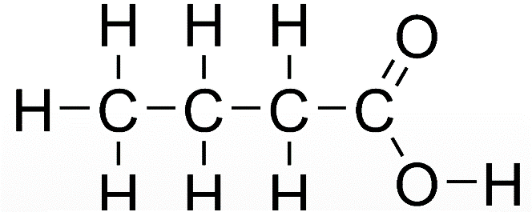

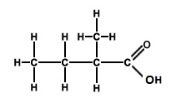

* 1. Name all possible structural isomers of the compound, if it does **not** react with sodium carbonate but instead has a pleasant, fruity odour.

(3 marks)

**Propyl methanoate**

**Ethyl ethanoate**

**Methyl propanoate**

**Methylethyl ethanoate (accept 1-methylethyl methanoate)**

**Accept any 3 for one mark each, maximum 3 marks.**

* 1. Other than the structural isomers that you have either named or drawn above, how many other structural isomers of the compound are possible?

(1 mark)

**9**

**Question excluded; mistake in question.**